**Green Finance and Climate Overview**

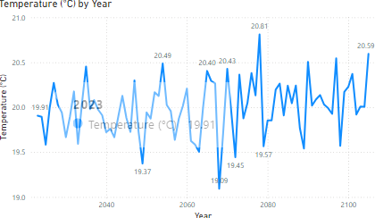

The "Temperature Trends Over Time" chart illustrates the changes in average temperature over a selected time period. By plotting the daily, monthly, or yearly temperature data on a line chart, this visualization makes it easy to observe long-term trends and seasonal variations. The x-axis represents the timeline, while the y-axis shows the temperature in degrees Celsius. An upward trend indicates rising temperatures, which could be linked to global warming, while a downward trend suggests cooling.

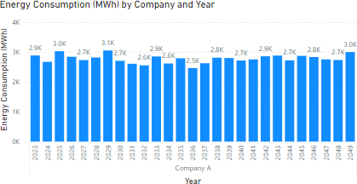

The "Energy Consumption Across Companies" visualization compares the energy consumption of various companies, measured in megawatt-hours (MWh). This bar chart presents each company on the x-axis, with the corresponding energy consumption values represented by the height of the bars on the y-axis. Taller bars indicate higher energy consumption, while shorter bars represent lower energy use. It allows for benchmarking energy consumption, identifying industry patterns, and highlighting opportunities for energy efficiency improvements.

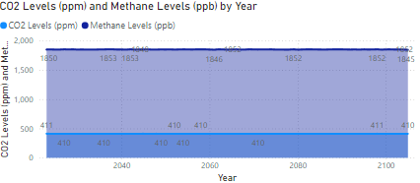

The "CO2 and Methane Levels Over Time" visualization illustrates the atmospheric concentrations of carbon dioxide and methane over a specific period. This dual line chart plots CO2 levels in parts per million (ppm) and methane levels in parts per billion (ppb) against time. The x-axis represents the timeline, while the y-axis (or y-axes) show the concentrations of the gases. The chart uses distinct lines for CO2 and methane to enable easy comparison of their trends. Rising lines indicate increasing levels of these greenhouse gases, which contribute to global warming, while stable or downward trends suggest effective emission control measures. This visualization is crucial for climate monitoring, policy evaluation, and raising public awareness about the importance of reducing greenhouse gas emissions.

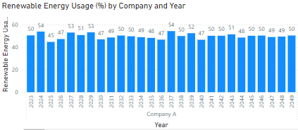

The "Distribution of Renewable Energy Usage" visualization displays how the percentage of energy consumption from renewable sources is spread across different entities. This visualization is crucial for understanding how widely renewable energy is adopted and identifying potential areas for improvement.

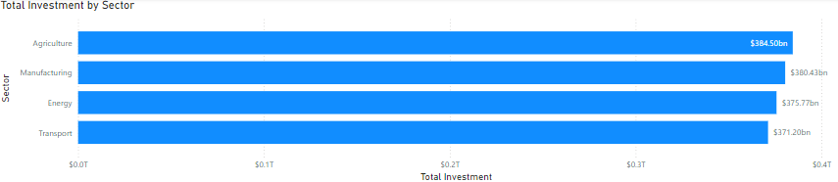

The "Total Investment by Sector" visualization compares financial investments across various industry sectors. The x-axis represents different Total Investments amounts in USD, while the y-axis shows the Sectors. Each bar represents a sector, with the height indicating the level of investment. This bar chart helps identify which sectors are receiving more financial resources, facilitating comparative analysis and highlighting investment trends. It is useful for stakeholders to understand funding allocation and identify potential investment opportunities or gaps.

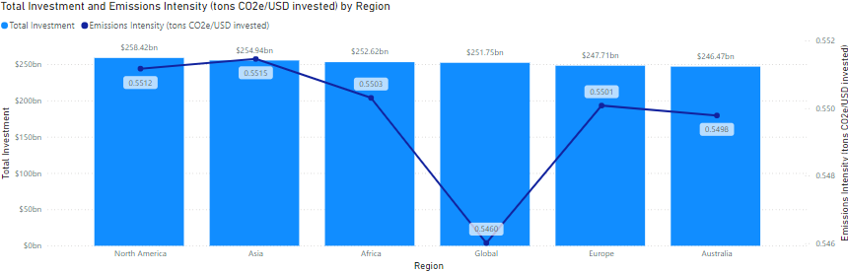

The "Emissions Intensity vs. Total Investment" visualization shows the relationship between financial investment and emissions intensity across different sectors or companies. The x-axis represents Region, while the Column y-axis shows total investment in USD invested. Each point represents a sector or company, with colour coding used for differentiation. The line y-axis emissions intensity in tons of CO2. This line and clustered column chart help to analyse how investment levels correlate with environmental impact, identifying sectors with high or low emissions intensity relative to their investment.

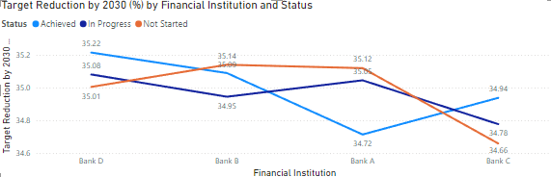

It provides insights into the alignment between targets and status by the financial institutions, and helps in monitoring and adjusting strategies to meet sustainability goals.